PROJECT REPORT

AIR QUALITY DASHBOARD

SUBMITTED BY
Name – Rajat Yadav
Registration No - 12308041
Section – K23DF
Roll no – 21
Course Title – INT374

Course Title – Data Analytics with Power BI
SUBMITTED TO
Mr. Pardeep Kumar

SCHOOL OF COMPUTER
SCIENCE AND ENGINEERING



1.) INTRODUCTION

1.1 Context and Public Relevance

Air quality has emerged as a critical public-health and environmental concern due to rapid urbanization, industrial emissions, vehicular load, and climatic conditions. Government agencies, researchers, and environmental authorities rely on data-driven air-quality monitoring to evaluate pollutant concentration, measure AQI levels, and implement mitigation policies.
This Power BI dashboard provides an integrated view of historical and real-time AQI patterns across locations, seasons, and major pollutants.

1.2 Purpose and Scope of the Report

The objective of this project is to transform raw environmental monitoring data into actionable air-quality intelligence. The dashboard explains AQI variations, pollution sources, geographic hotspots, and seasonal trends.
Scope includes:
• AQI trend analysis across months/years
• Comparative pollutant analysis (PM2.5, PM10, NO2, SO2, O3, CO)
• Region-wise and city-wise AQI evaluation
• Peak pollution period identification

1.3 Target Audience
The dashboard and report are intended for:
- Environmental authorities and civic bodies
- Public-health researchers
- Urban-climate analysts
- Academic evaluators assessing Power BI skills

2.) PROBLEM STATEMENT

2.1 Public Challenge
AQI datasets contain thousands of observations that are difficult to interpret without visualization. Citizens and regulators require live analytics to track deterioration, issue alerts, and plan responses.

2.2 Key Challenges Addressed
- Lack of unified AQI visibility across locations
- Difficulty identifying daily/seasonal pollution spikes
- No quick comparison of pollutant concentration
- Lack of hotspot identification for policy interventions

2.3 Dashboard Objectives
- Deliver AQI score visibility at regional and city level
- Provide pollutant-wise composition analytics
- Highlight severe, moderate, and satisfactory zones
- Support environmental decision-making

3.) DATASET DESCRIPTION

3.1 Data Source
The dataset used for this project is the India Multi-City Air Quality Dataset (100K Rows), sourced from Kaggle. It consolidates air-pollution measurements collected across multiple Indian cities and monitoring locations. The data is structured in CSV format and contains timestamp-based pollutant readings that support exploratory and time-series analysis.

Metadata Field Detail
- Dataset Name India Multi-City Air Quality Dataset
- Data Type Atmospheric Air-Quality Monitoring Data
- File Format csv
- Dataset Provided By India Multi-City Air Quality Dataset (100K+ Rows)
- Tool Used for Analysis Microsoft Power BI
- Time Period Covered As per available recorded timestamps in the dataset

3.2 Key Attributes in the Dataset

City – Name of the Indian city where monitoring was conducted
• Date/Time – Timestamp of recorded atmospheric readings
• AQI – Air Quality Index value for the corresponding timestamp
• AQI_Bucket – Categorical classification (Good, Moderate, Poor, Very Poor, Severe)
• PM2.5 – Fine particulate matter concentration (µg/m³)
• PM10 – Coarse particulate matter concentration (µg/m³)
• NO2 – Nitrogen Dioxide (µg/m³), largely vehicular/industrial
• SO2 – Sulphur Dioxide (µg/m³), largely industrial and combustion-based
• CO – Carbon Monoxide concentration
• Ozone (O3) – Surface-level ozone concentration
• Benzene, Toluene, Xylene (where available) – Industrial/solvent-based pollutants
• Station or Location – Monitoring site or measurement point

4.) METHODOLOGY AND DATA PREPARATION

4.1 Analytical Methodology
The analysis follows a descriptive and diagnostic analytics approach to evaluate air-quality behaviour across Indian cities. Power BI is used to convert raw pollutant readings into interactive dashboards that highlight AQI variations, pollutant dominance, and city-level risk profiles.
Key analytical steps include:
• Importing the CSV dataset into Power BI
• Profiling pollutant fields such as PM2.5, PM10, NO2, SO2, CO, and O3
• Creating AQI-based severity buckets to classify risk levels
• Designing time-series charts to analyse monthly and seasonal patterns
• Building geographic maps for city-wise hotspot detection
• Integrating KPI visuals to highlight average AQI, maximum recorded AQI, and most-polluted cities
• Comparing pollutant concentration across regions to identify dominance and contributing factors
The methodology emphasises visual interpretation of large-volume atmospheric readings to support public-health awareness and policy decisions

5.) DETAILED ANALYSIS: GEOGRAPHIC AQI DISTRIBUTION

5.1 AQI Distribution by Region
The region-wise analysis highlights the concentration of air-pollution severity across different geographic zones of India. This distribution reflects variations in population density, vehicular intensity, industrial presence, agricultural burning, and climatic dispersion. Certain regions consistently record significantly higher AQI values, indicating high-risk environmental zones that require regulatory attention and seasonal mitigation planning.

6.) POLLUTANT COMPOSITION AND DOMINANCE

6.1 Particulate Matter Dominance (PM2.5 and PM10)
The dataset highlights that particulate matter is the primary pollutant influencing India’s AQI performance. PM2.5 and PM10 consistently contribute the highest proportion of air-quality deterioration across cities.
• PM2.5, which consists of fine respirable particles, frequently exceeds recommended thresholds and drives Severe and Very Poor category classifications.
• PM10, representing coarse dust and construction-linked emissions, remains elevated in dense urban locations and dry climatic zones.
Interpretation:
• AQI deterioration is predominantly linked to combustion residue, construction dust, biomass burning, and vehicular emissions.
• Fine particulate matter demonstrates the highest health risk due to lung-penetration capability.

6.2 Product Popularity and Market Segmentation
Gaseous components represent secondary but significant contributors.
• NO2 levels correlate with high vehicular density and traffic congestion, particularly in metro corridors.
• SO2 concentrations reflect industrial combustion and thermal-power output.
• CO measurements indicate incomplete fuel combustion in transportation-dense locations.
• Surface-level ozone (O3) fluctuates seasonally and intensifies under high-temperature photochemical conditions.
Interpretation:
• Gaseous pollutants reinforce the contribution of transportation and industrial energy use.
• Secondary pollutants such as ozone emerge more strongly in summer and late-afternoon cycles
Pollution intensity demonstrates notable cyclic variation.
• Winter months exhibit the highest particulate concentration due to atmospheric inversion, limited vertical air mixing, and post-harvest residue combustion.
• Monsoon improves dispersion, lowering particle concentration and delivering better AQI outcomes.
• Summer supports dispersal for particulates but increases ozone reactivity.
Interpretation:
• Seasonal cycles must be factored into regulatory planning
• Northern-plains winter behaviour represents a recurring intervention challenge

7. DETAILED ANALYSIS: AQI TRENDS OVER TIME

7.1 Temporal Behaviour and Trend Identification
The time-series visualizations created in Power BI highlight clear variations in AQI values across daily, monthly, and seasonal intervals. These charts indicate visible cycles of atmospheric deterioration and improvement influenced by meteorology, urban activity, and agricultural practices.
The long-range temporal view reflects periods of sharp pollution escalation, particularly in winter, contrasted with gradual improvement during monsoon. These temporal dynamics are essential for forecasting public-health risk and resource deployment.

7.2 Monthly and Seasonal Escalation Cycles
Monthly aggregation reveals repeated peaks during October–January, a period associated with cold-weather inversion, stubble-burning activity, and increased residential combustion.
Conversely, July–September consistently demonstrate lower AQI levels, reflecting rainfall-driven particulate settling and atmospheric cleansing.
Interpretation:
• Winter conditions align with Poor, Very Poor, and Severe categorizations
• Monsoon moderates particulate concentration and improves category distribution

7.3 Daily and Hourly Fluctuation Patterns
Short-interval examination shows that AQI often intensifies during morning traffic periods and late-evening congestion, when vehicular combustion peaks.
Afternoon dispersion can temporarily reduce pollutant load due to higher temperatures and atmospheric mixing. These micro-patterns support localized traffic-management decisions. This regional insight enables businesses to allocate resources more effectively and design location-specific sales strategies.

8. CONCLUSION AND RECOMMENDATIONS

8.1 Conclusion
The Air Quality Index Dashboard developed using Microsoft Power BI successfully transforms large-scale atmospheric records from multiple Indian cities into clear, interpretable, and decision-oriented environmental intelligence. Through systematic data import, preparation, transformation, and visualization, the project delivers a consolidated view of pollutant behaviour, geographic hotspots, and seasonal AQI deterioration.
The analysis confirms that particulate matter (PM2.5 and PM10) is the principal determinant of Poor to Severe AQI categories across most locations. Urban transportation corridors and industrial clusters demonstrate consistently elevated pollutant intensity, whereas coastal and lower-density regions show comparatively better dispersion.
Time-series assessment reveals a recurrent seasonal escalation cycle, with winter months representing the most critical exposure period, influenced by meteorological inversion, combustion residues, and agricultural burning. Monsoon intervals significantly reduce particulate concentration, demonstrating strong environmental cleansing effects.
Overall, the dashboard acts as an effective environmental monitoring and regulatory-support mechanism, enabling pollution-control bodies, researchers, and policymakers to identify critical zones, allocate mitigation resources, and plan seasonal interventions.

8.2 Recommendations
Based on the insights generated, the following interventions are recommended to improve air-quality outcomes:
- Strengthen Particulate-Control Measures
PM2.5 and PM10 require targeted regulation through construction-dust control, roadside suppression, industrial-stack monitoring, and elimination of open-burning activities.
- Improve Vehicular-Emission Accountability
Urban AQI hotspots correlate strongly with traffic flow. Congestion pricing, EV incentives, public-transport prioritization, and inspection-compliance programs can reduce mobile emissions.
- Enforce Industrial Emission Standards
Thermal plants, industrial clusters, and refinery zones should adopt sulphur-scrubbing, chimney filters, fuel-switching, and real-time emission logging.
- Implement Seasonal Response Frameworks
Winter-specific emergency measures—such as graded action plans, construction shutdown windows, and fuel-use restrictions—can mitigate critical exposure periods.
- Expand Air-Monitoring Infrastructure
Additional sensor deployment across Tier-2 and Tier-3 cities will improve data granularity and support fair regulatory enforcement.
- Integrate Predictive Modelling
Incorporating forecasting and simulation techniques can support anticipatory governance instead of reactive policy.

8.3 Future Scope
Future enhancements to the dashboard may include:
• Integration of real-time IoT sensor feeds for live AQI surveillance
• Machine-learning-based AQI forecasting for proactive enforcement
• Meteorological correlation analysis (wind, humidity, temperature) to model pollutant dispersion
• Health-impact scoring and hospital-correlation dashboards to quantify respiratory exposure
• Deployment on Power BI Service, enabling mobile public access and collaborative review
These extensions would expand the project from a descriptive environmental dashboard into a comprehensive air-quality risk-management system, supporting long-term ecological sustainability and public-health protection.

9.) POWER BI DASHBOARD SCREENSHOTS

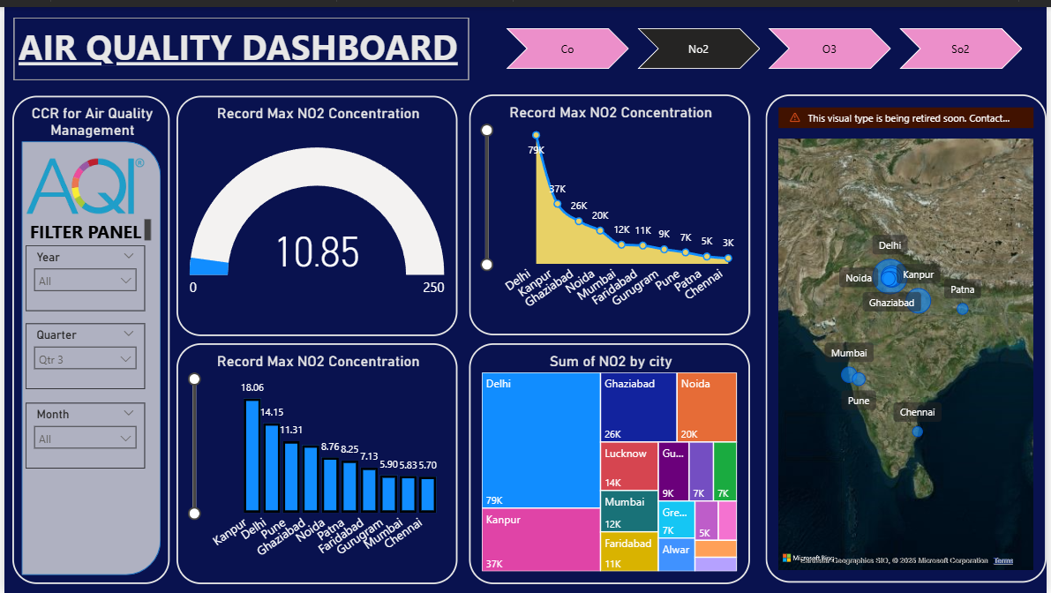

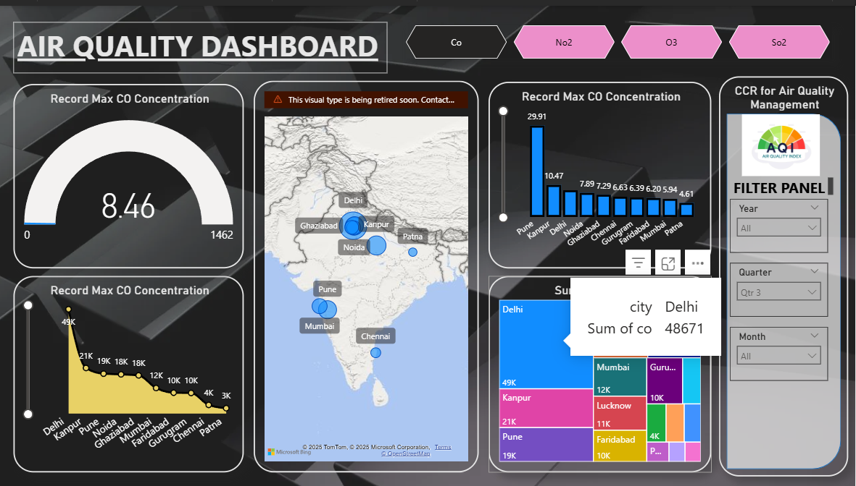

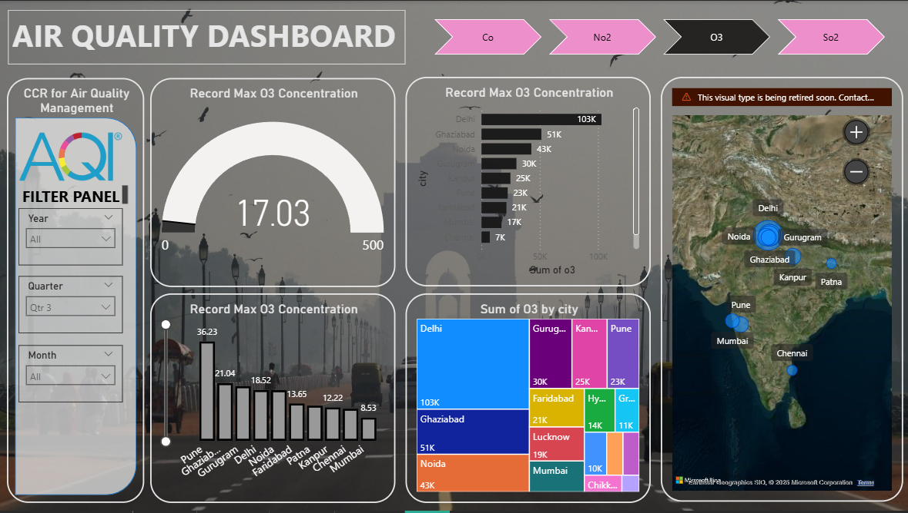

10.) LinkedIn Link and Screenshot
LinkedIn Link - https://www.linkedin.com/posts/rajat-yadav21_powerbi-aqi-datavisualization-activity-7407129315877875712-bCLN?utm_source=social_share_send&utm_medium=member_desktop_web&rcm=ACoAAE3AtL4BUwF8rx8-a5biITr7RgU8o1nXMZo

10.2. LinkedIn Post Screenshot (SS)
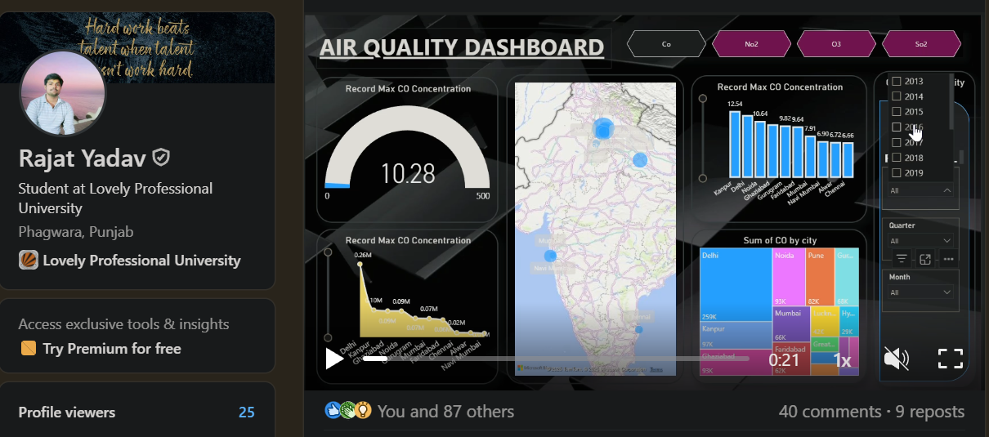

GOOGLE DRIVE LINK-
https://drive.google.com/drive/folders/1r79SyKMNqNJO-ZVnxxryG_bCrY1geY--?usp=drive_link

DATASET SOURCE LINK- India Multi-City Air Quality Dataset (100K+ Rows)

